6 Motor Assemblies

Vitamins
2 M3 cap screw x 16mm  4 M3 cap screw x 12mm  4 M4 cap screw x 16mm  2 NEMA17 x 47mm stepper motor  6 Nyloc nut M3 | 4 Nyloc nut M4  8 M3 cap screw x 10mm  14 Washer M3 x 7mm x 0.5mm  4 Washer M4 x 9mm x 0.8mm  8 Star washer M3 x 0.5mm

Printed parts
1 z_motor_bracket_lhs.stl  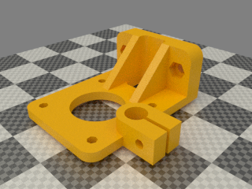 | 1 z_motor_bracket_rhs.stl  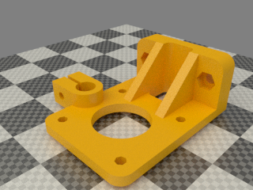
2 z-axis_lead_screw_clamp.stl
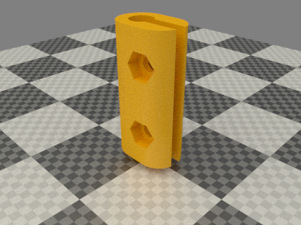

Assembly

- Fit all the nyloc nuts into their nut traps.
- Fit the M3 x 16mm cap screws to the bar clamps with plain washers.
- Attach the motor using four M3 x 10mm cap screws, star washers and plain washers. Wires from the left hand motor routes on top of the base to the left and meets up with the wires from the Y motor and goes through the gantry and under the right stay. The wires from the right hand motor goes through the wide slot just behind it.
- Degrease the motor shafts before fitting the Z coupling, but be very carefull you dont get degreaser down the shaft in the steppers. Holding them upside down should help
- Fit the coupling loosely for now. Insert a M3 screw and washer but do not tighten fully
- Twist the motor wires in pairs. Red / blue are one pair and green / black the other pair. The quickest way to twist them is by using an electric drill. Tie a knot in the far end and put it in the chuck. The reason they are twisted is to minimise the radio frequency emissions.
- Attach the motor assemblies to the gantry using M4 x 16mm cap screws and washers. Note that the motors rest on the base and the bar clamps face inwards.

